**1) Title of project- Traffic Violations in Maryland, Montgomery**

**Group members:**

1. Kim Min Su
2. Kim Won Hyun
3. Liu Siyuan Shawn
4. Zhang Linghan
5. Tan Chin Won

**2) Insights of this project**

The preliminary analysis of the data shows that traffic violations tend to occur at certain locations. The distributions of traffic violations occur at certain borderlines and concentrated areas in Montgomery Country, Maryland. The analysis of this distribution will lead us to discover the causes of violation.

In each of the past five years, police in the state have made more than 20,000 arrests for driving under the influence of alcohol, according to Maryland State Police data.

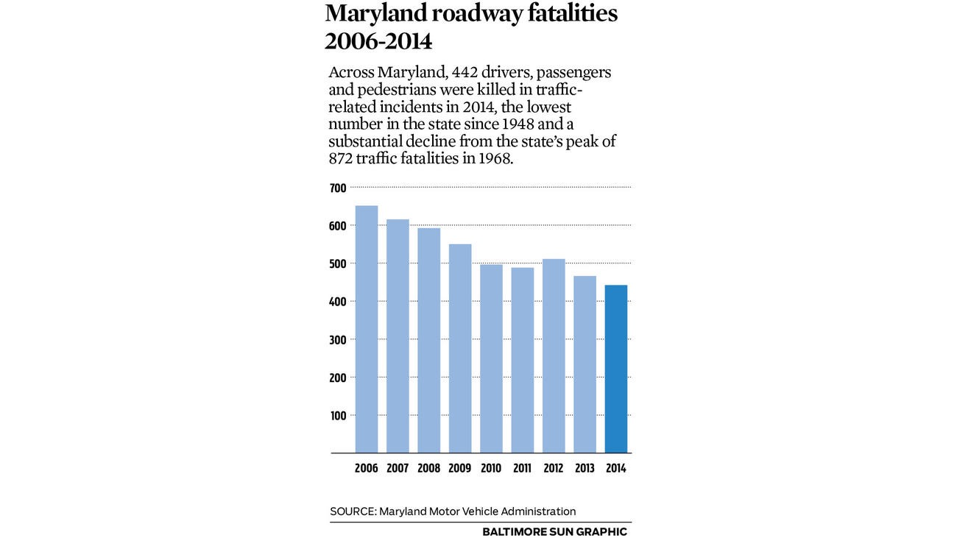

*Fig. 1*

Despite the slow and steady decline death rate in Maryland due to traffic violations, there is still somebody killed on the road. On average in 2014 – **there are still 30 percent of the year's traffic deaths.**

Source: [http://www.baltimoresun.com/news/maryland/commuting/bs-md-traffic-fatalities-20150324-story.html#page=1](http://www.baltimoresun.com/news/maryland/commuting/bs-md-traffic-fatalities-20150324-story.html%23page=1)

Hence, we would like to find out

1. How does the violation locations distribute as is?
2. How does these traffic violations differ from different genders?
3. Does the traffic violations have seasonal behaviours and characteristics?

**3) Analysis**

There are 684754 entries of data dated from 01/01/2012 to 07/04/2015.

For each observation, the information includes:

|  |  |  |  |  |  |
| --- | --- | --- | --- | --- | --- |
| Date Of Stop | Time Of Stop | Agency | Sub-Agency | Description | Location |
| Latitude | Longitude | Accident | Belts | Personal Injury | Property Damage |
| Fatal | Commercial License | HAZMAT | Commercial Vehicle | Alcohol | Work Zone |
| State | Vehicle Type | Year | Make | Model | Colour |
| Violation | Type | Charge | Article | Contributed To Accident | Race |
| Gender | Driver City | Driver State | DL State | Arrest Type | Geolocation |

The core features of the observations for the analysis are determined as:

* Location (Latitude, Longitude)
* Gender
* Vehicle information (Makes, Car Type, Model)
* Violation information (Type of Violation, Time and Date)

**4) Distribution of the core features**

Fig. 2a shows us the spread where those accidents usually happened.

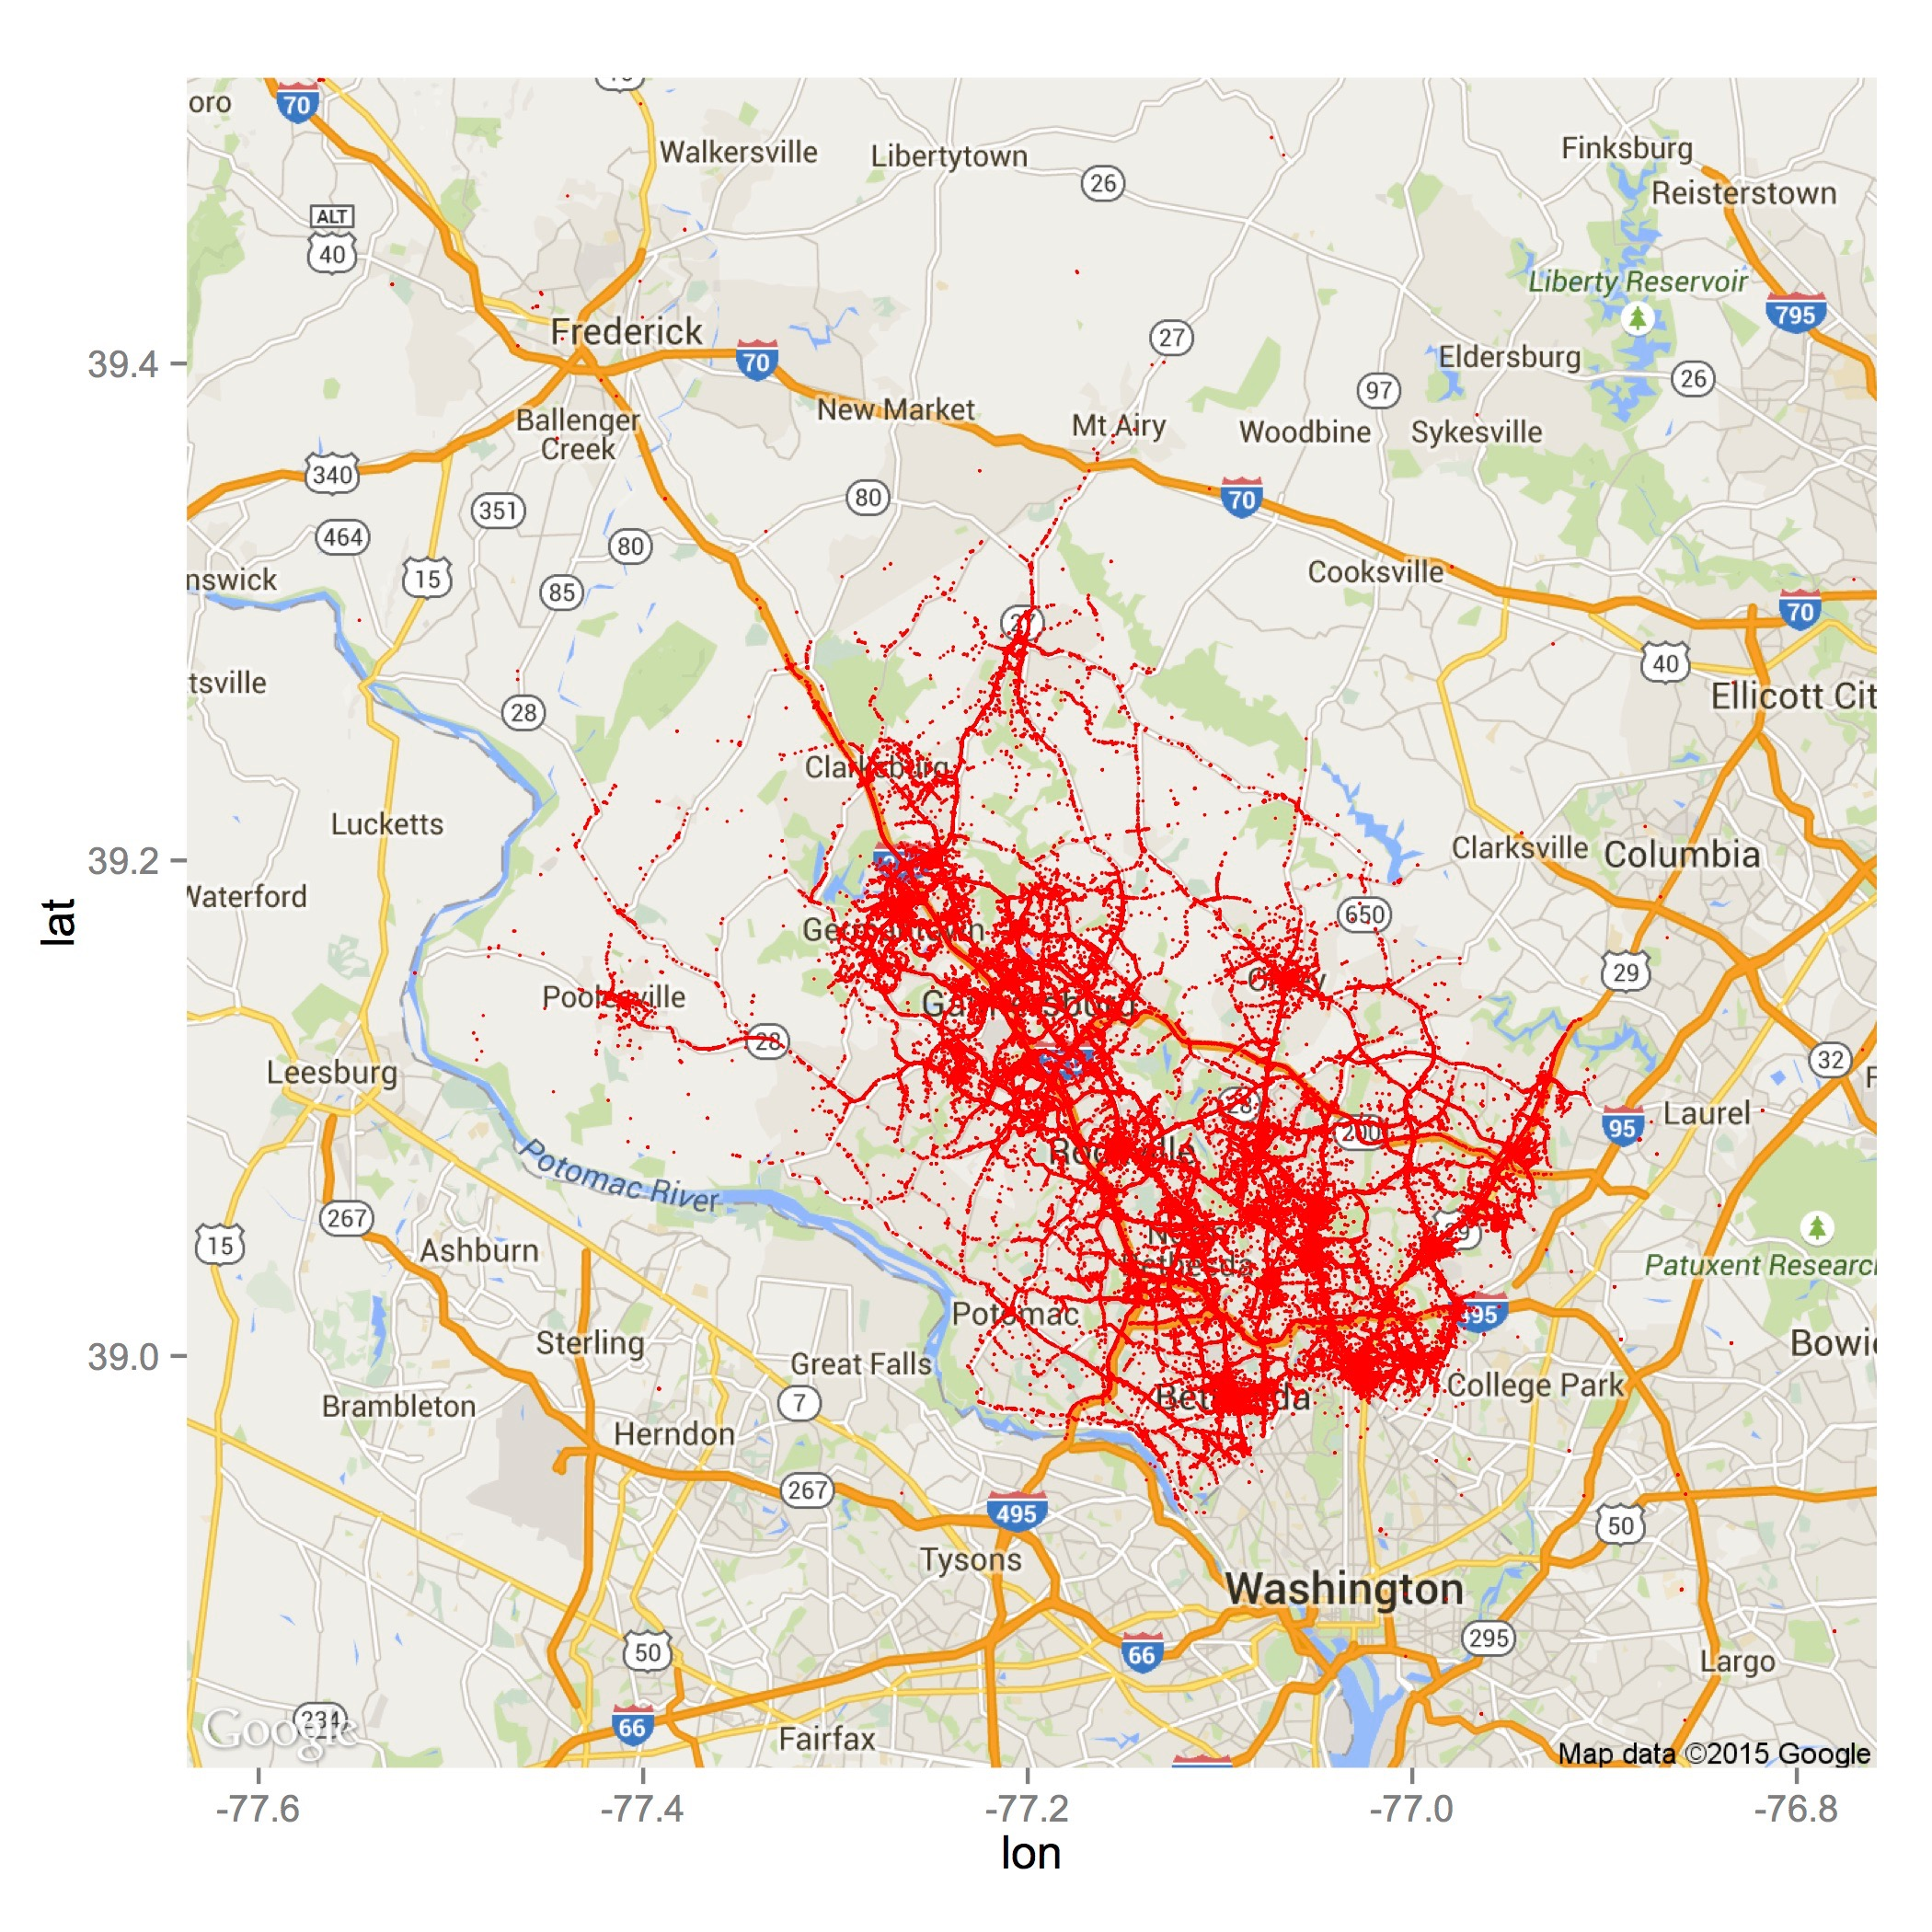

*Fig 2a. Point Distribution of Locations*

**Legend**

Ion- Longitude

Lat- Latitude

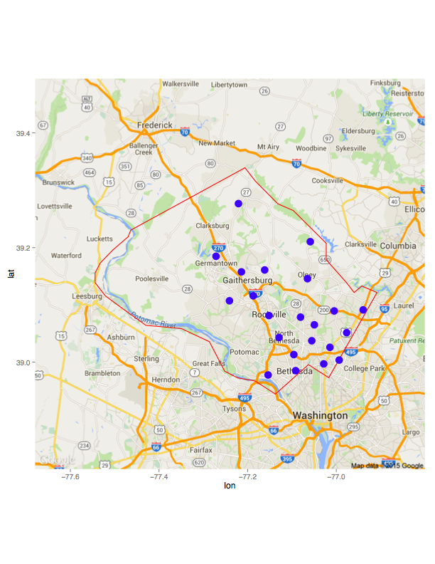Fig.2b shows the areas where traffic violations happen the most in each district.

*Fig. 2b*

**Legend**

Concentrated area where traffic violation occurs in each district

Fig. 3a gives us the overview of the gender that violated the traffic rules.

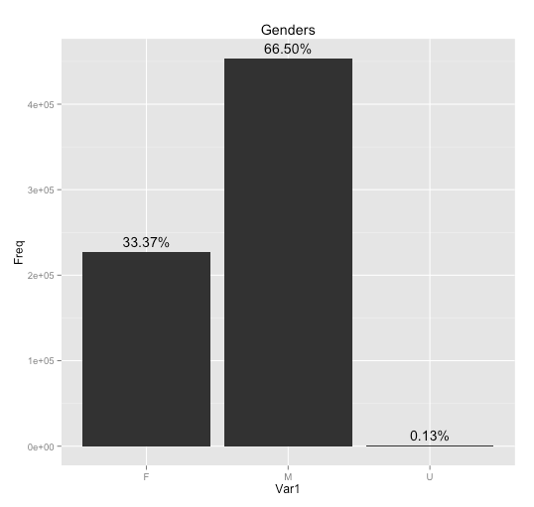

*Fig 3a. Gender Distribution*

Legend

* Var 1- Variable 1
* F- Female
* M- Male
* U- Unknown

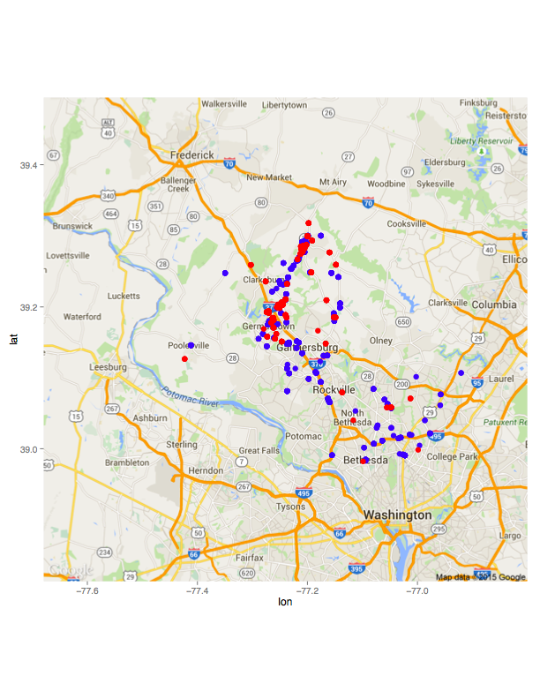Fig.3b shows the locations where different gender violates the traffic regulations under the influence of alcohol.

Fig.3b

**Legend**

Male

Female

**Analysis**

Most of the accidents (under the influence of alcohol) happened at the city of Gaithersburg and majority are males.

Fig. 4 shows us the top 5 manufactures of the car that violated the traffic rules.

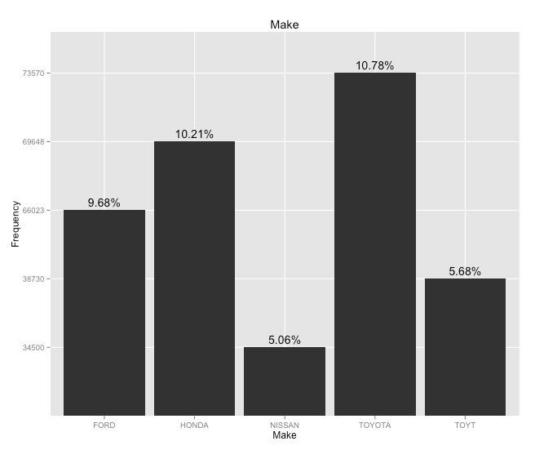

*Fig 4. Car Manufacturer Distribution (Top 5)*

Fig.5 shows us the top 5 car models that violated the traffic rules.

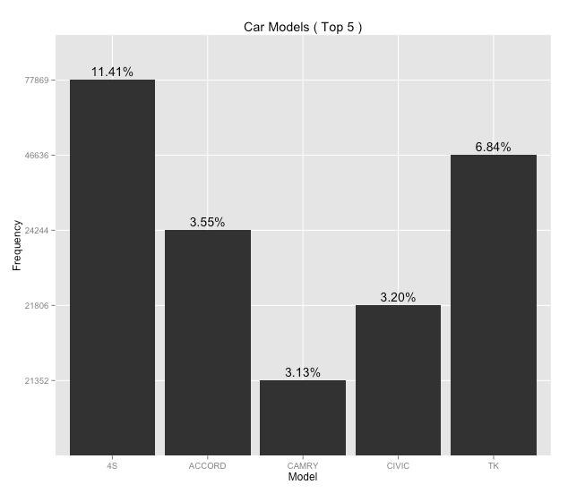

*Fig 5. Car Model Distribution (Top 5)*

Fig.6 shows us the top 5 types of vehicle that violated the traffic rules.

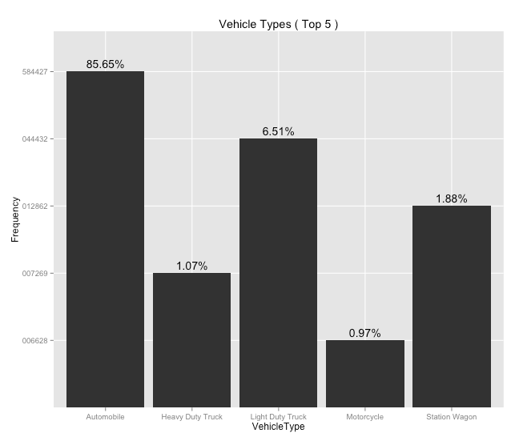

*Fig 6. Vehicle Types Distribution (Top 5)*

Fig.7 shows us the top 5 types of traffic violation happened in the country.

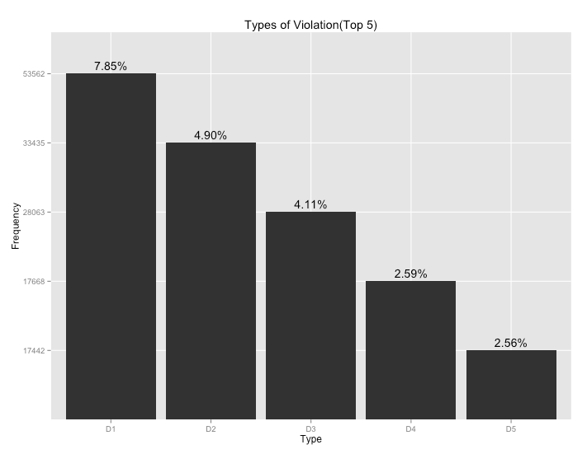

*Fig 7. Violation Type Distribution (Top 5)*

**Legend**

D1- Driver failure to obey properly placed traffic control device instructions

D2- Failure to display registration card upon demand by police officer

D3- Driving vehicle on highway with suspended registration

D4- Operator not restrained by seatbelt

D5- Failure of individual driving on highway to display license to uninformed police on demand